|  |  |
| --- | --- |
| **Assignment No** | <<enter Assignment No>> |

Assignment Number - 03

**Title :** Design a Flutter application where user input a name and mobile number of person and show on next screen in different colors and font

**Theory :**

**Global Key-**

A key that is unique across the entire app.

Global keys uniquely identify elements. Global keys provide access to other objects that are associated with those elements, such as BuildContext. For StatefulWidgets, global keys also provide access to State. When creating the form, provide a GlobalKey. This uniquely identifies the Form, and allows validation of the form in a later step.

**TextFormField-**

TextFormField widget is used to take input from the user in flutter. This is a simple and easy user input widget in flutter.

We can perform any operation on that user input data using TextFormField. You can use that user input, can send and show that input. You can store it into a TextEditingController type object. It provides additional functionality such as Validation and integration with other FormField widgets.

**TextEditingController**

A controller for an editable text field. Whenever the user modifies a text field with an associated TextEditingController, the text field updates value and the controller notifies its listeners.

A TextEditingController can also be used to provide an initial value for a text field. If you build a text field with a controller that already has text, the text field will use that text as its initial value.

A more powerful, but more elaborate approach, is to supply a TextEditingController as the controller property of the TextField or a TextFormField.

**Source Code:-**

import 'package:flutter/material.dart';  
  
class MyForm extends StatefulWidget {  
 @override  
 _MyFormState createState() => _MyFormState();  
}  
  
class _MyFormState extends State<MyForm> {  
 String _name = 'ved namde';  
 String _phoneNumber = '9322245480';  
  
 @override  
 Widget build(BuildContext context) {  
 return Scaffold(  
 appBar: AppBar(title: Text('My Form')),  
 body: Padding(  
 padding: EdgeInsets.all(16.0),  
 child: Column(  
 children: [  
 TextField(  
 onChanged: (value) {  
 setState(() {  
 _name = value;  
 });  
 },  
 decoration: InputDecoration(labelText: 'Name'),  
 controller: TextEditingController(text: _name), *// Pre-fill with name* ),  
 SizedBox(height: 16.0),  
 TextField(  
 onChanged: (value) {  
 setState(() {  
 _phoneNumber = value;  
 });  
 },  
 decoration: InputDecoration(labelText: 'Phone Number'),  
 keyboardType: TextInputType.*phone*,  
 controller: TextEditingController(text: _phoneNumber), *// Pre-fill with phone number* ),  
 SizedBox(height: 16.0),  
 ElevatedButton(  
 onPressed: () {  
 *// Perform form submission logic here* print('Name: $_name');  
 print('Phone Number: $_phoneNumber');  
 },  
 child: Text('Submit'),  
 ),  
 ],  
 ),  
 ),  
 );  
 }  
}

**Output:**

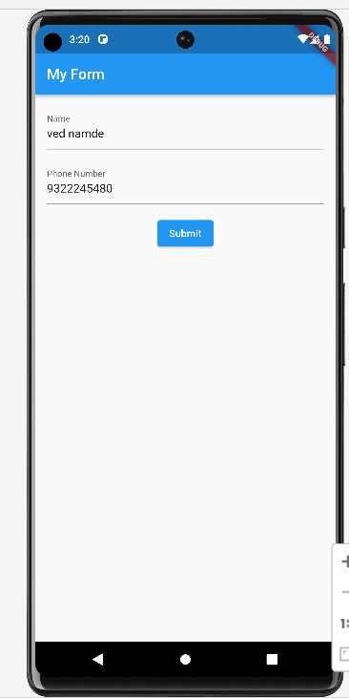

**Conclusion : in this assignment I have learn about globel keys.**